LENTSWE LA KGOTLA…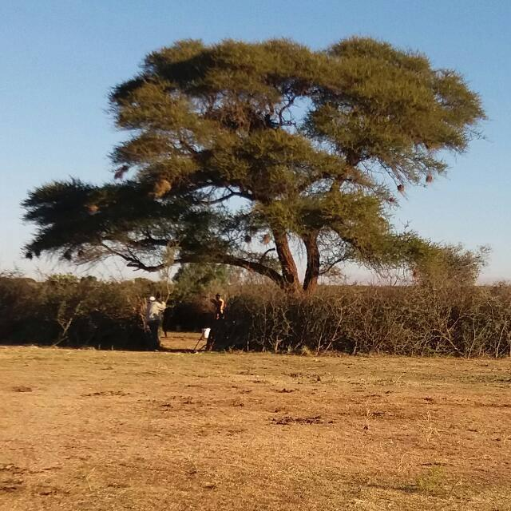
SEMESTER REPORT
FOR THE 1st January2021 till 30 June -2021-
KGOTLA YA GA TSHITE-BATLHAPING BA GA MAIDI
NORTH WEST PROVINCE
Matlhagola-tsela/Forward by
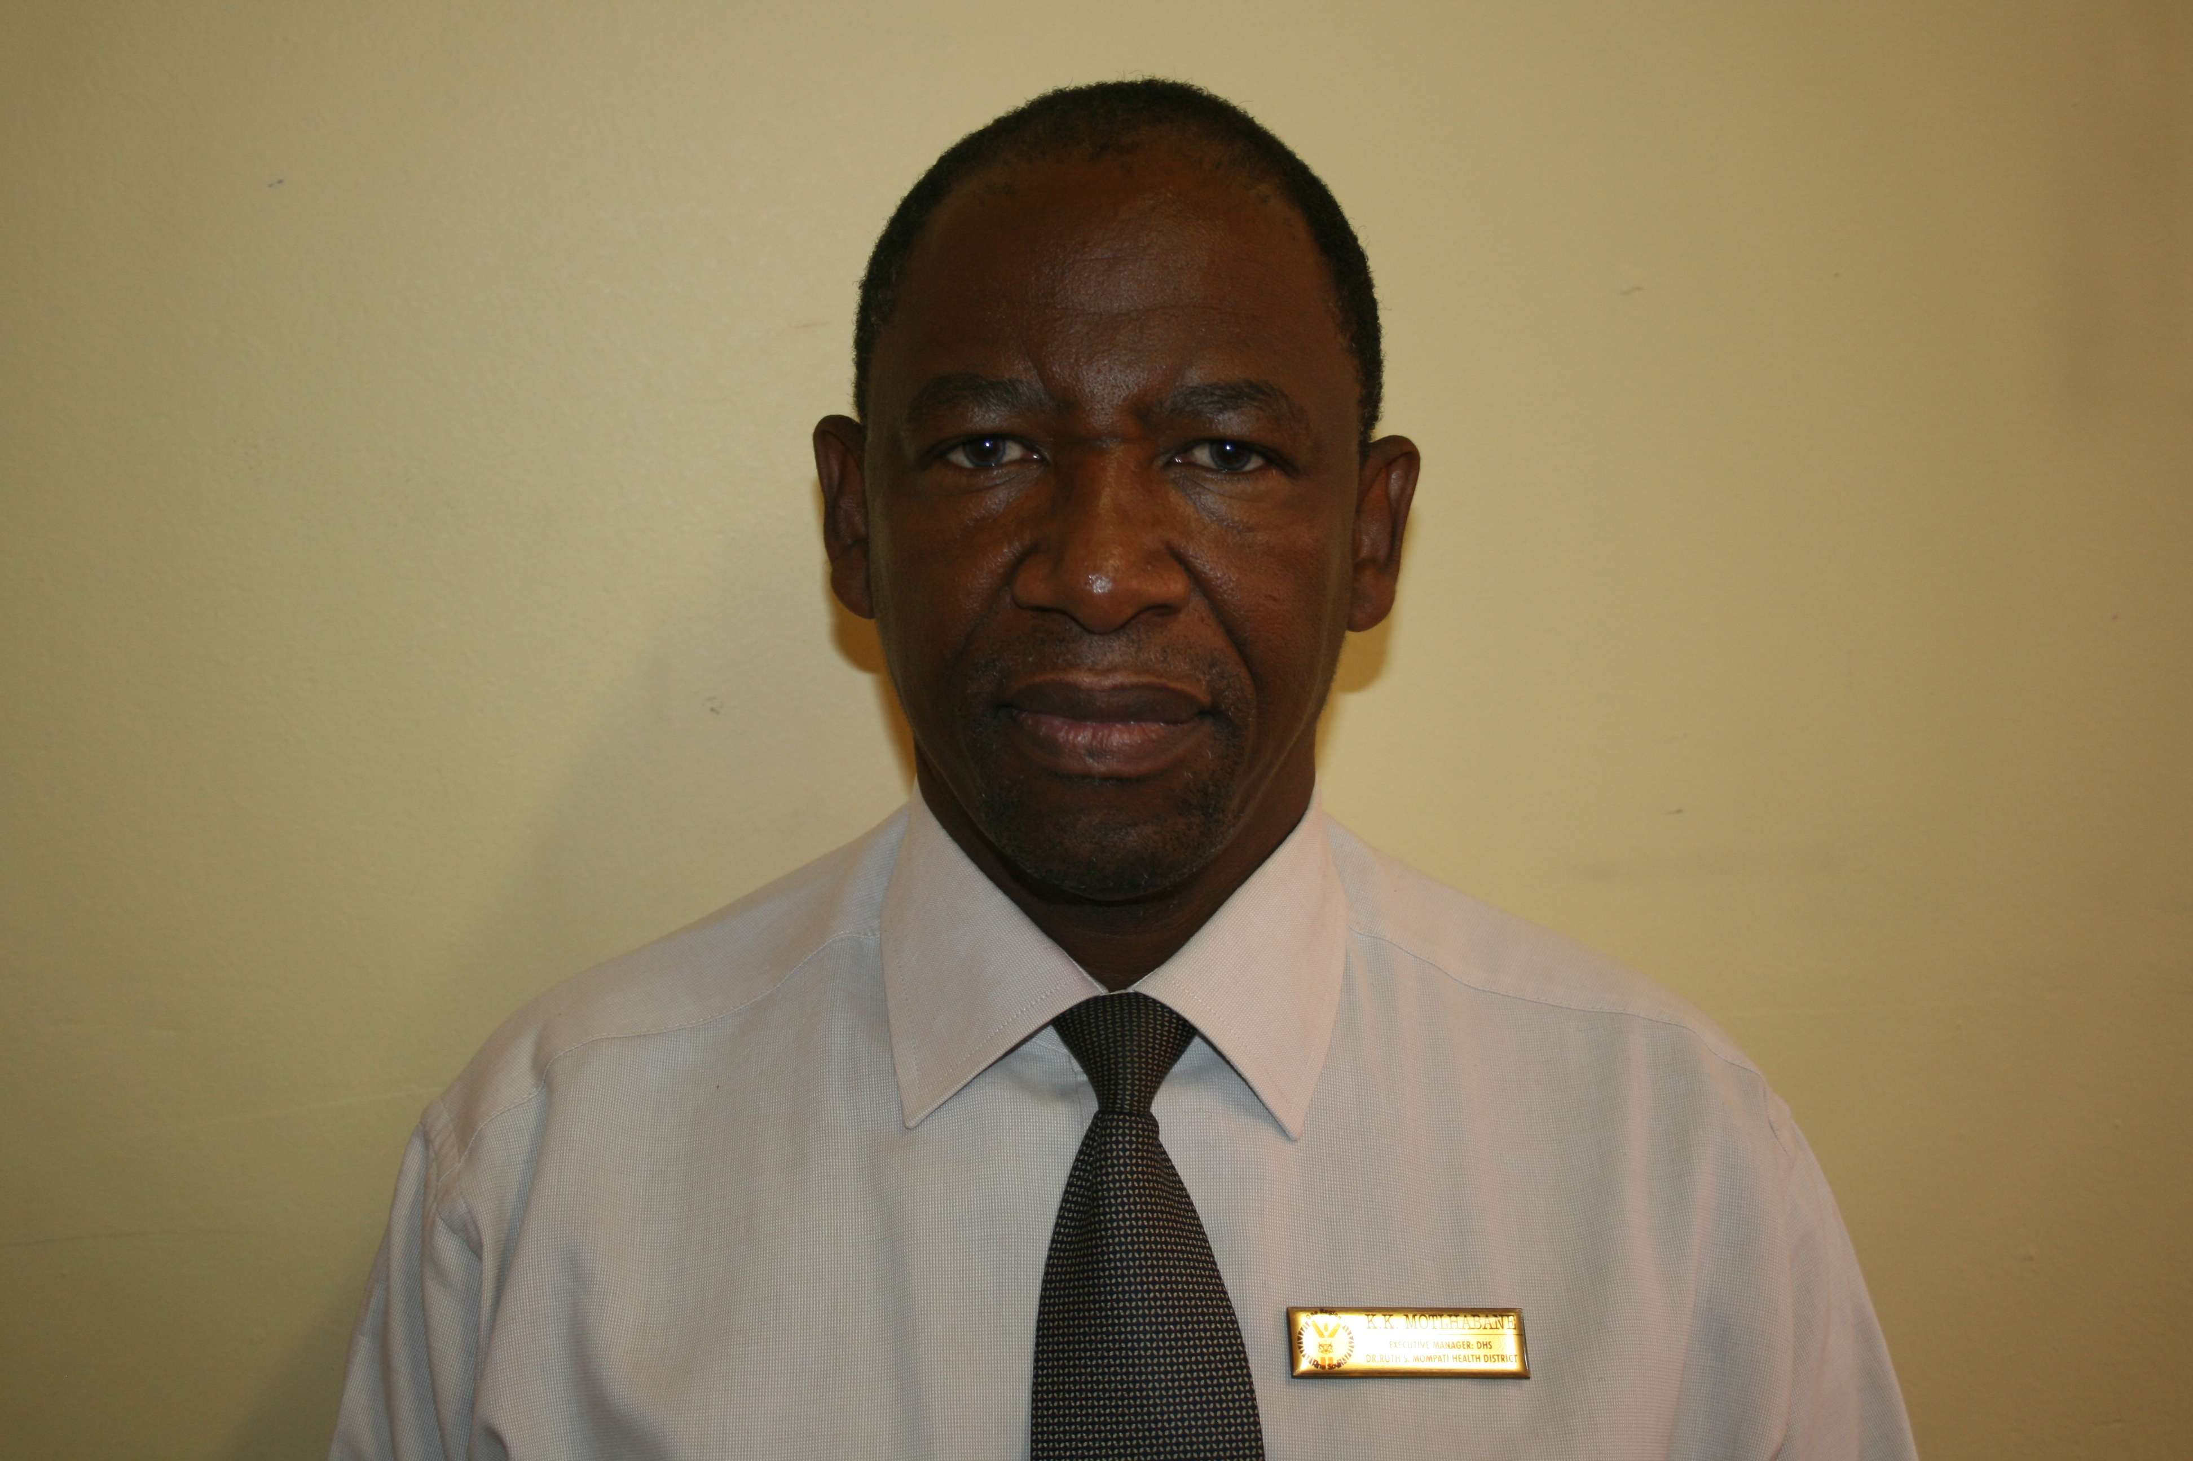
Bagaetsho dumelang!
Pilediwa ea lwelwa, go bolelelwa go phalwa ke goikutlwela.
Se se kwadilweng fa ke go lotlisetsa fela dintlha kgolo tsa lentswe la kgotla jaaka lekwalo kgang la rona la kgotla le rata go fitlhelela motho mongwe le mongwe go mo gakolola ka ditiragalo le tsamaiso ya morafe wa rona.
Lentswe le le tla rebolwa fa go kgonagala ka dithuso tsa sponsors ga bedi ka ngwana go gatisa dintlha kgolo gore ba ba sa duleng mo gae ba utlwe tsa pudi ya tsela sentle.
Fela pela e tlhokile mogatla ka go romeletsa.
A Pula ene!!

Table of Contents of the Report
Item | Page No
Background Information
- Governance structure review traditional leadership of Picong
Traditional leadership structure
- Meetings –Dipitso
- Maleta motse/Mabogo dinku aa thebana-
Arts; Culture & Sports
- Sporting facilities Heritage celebrations
- Community library initiatives
- Working with government
- Roads and lighting & electricity etc.
Conclusion

Dintlha kgolo tsa kgotla ya rona-
Re kgona tse tsotlhe ka tshegetso ya Modimo le Batho.
Re ratile go tsenela dipitso go sedimosetsa baagi ba morafe wa rona ka tse di tlhokegang go tokafatsa botshelo jwa bone mo ba nnang gonne.
Ngwaga 2021 e simolotse ka go nna mo kgatelelong ya kanamo ya botlhoko jwa Covid-19 “second wave” , ee dirileng gore president Ramaphosa a busetse naga ko Level3 ee lekanyeditsweng. Dipitso metsameko, manyalo le metsamao e eleditswe go ya ka mabaka a go thibela kanamo ya corona virus.
kopano ee kgethegileng ya dikgosi tsa Ba ga Maidi e nnele ka 19/1/2021 go le mosa ka tse di latelang:-Diphitlo di nne fela di ura tse pedi: ga gona tebelelo;ga gona moletlo wa lenyalo,metsameko , palo ya dikopano le dipitso di emisitswe etc.
Diphetogo mo lekgotleng la kgotla
Letlhaku le lesha
Letlhaku le lesha le agelwa mo go le le gologolo, mme se ke nnete jaaka re bone fa ngwaga ya 2021 e tshimolola go nna le ntshafalo ka go amogelwa molekgotla yo mosha mo kgotleng.
Rre Senyatso John Mocwiri, yoo mo malatsing a bogodi one a tsena mo lekgotleng ka letsatsi la 6 Ferekgong 2021, mme a tsena ka gangwe fela mo tirong ya go tsenela kago le kitlano ya malapa.
Yo mongwe yoo tseng sentle, ka kgwedi e ke molekgotla wa gale rre Itlhobogeng Sebico yo ka jaana a simololang dingwaga tsa bogosi mo gae , mme leene o ikaile jalo ka letsatsi la 6 Ferikgong 2021
Re ba eleletsa katlego mo tirong e ya bodiredi le boithaopo mo bodireding setshaba.
Jaanong lekgotla le ntse jaana:
- Rre Phomolo Kwena
- Rre Mmutle Mongwaketse
- Rre Legabura Goitseone
- Rre Itlhobogeng Sebico
- Rre Senyatso John Mocwiri
- Rre Kagiso Gasetlolwe(New-still at work)

Balekgotla ba thusa Kgosi ya motse ka go seka seka matshwenyego a morafe , mme ba nna gone ko kgotla ka malatsi aa latelang:- Mosopologo/Monday le Labone/Thursday mo mosong ura kgotsa tse pedi fela mo bekeng
Baagi ba rotloediwa go dirisa balekgotla go tlisa dikgakololo le dingongorego.
Ke maikaelelo a Kgosi go ngokela bomme basadi ba ba bedi go nna madula kgotla go thusa bo rre.

Ditiro tsa Maleta-Motse/ Community guardians/Formation of village
To ensure broad-based community participation the committee of elders/advisors or guardians called in vernacular language as Maleta-motse were established to take charge of various community committees and to act as the “eyes and ears” of the traditional committee.
The intention of the guardians was to ensure that they advise the core Balekgotla on matters of community interest. A list of maleta motse will be attached to this review report.

TRADITIONAL LEADERSHIP STRUCTURE
Balekgotla started meeting every Mondays and Thursdays in the morning for two hours to listen to any case/issues or complaint from the community in the absence of Kgosi. This created an opportunity for committees to give any interim reports to them in between monthly meetings.
Meetings/Dikopano /Dipitso
Dipitso tsa morafe di ne di tsena bonnye gangwe ka kgwedi, mme pitso ya morafe e epiwa ke kgosi.
Ka lebaka la Covid19 reile la kgorolesega go ka nna le dipitso mme reile ra tshwara pitso e kgolo ka magare a Motsheganong or 18 May 2021 go atlha-atlha ka bosinyi le go thubelwa mo matlong.
Reile ra tlhopa maloko a Community policing forum, re solofela fa ba tla thusana le sepodisa le maletamotse a rona.Pitso ene e tsenetswe ke batho bale 136.
Fa Kgosi a se gone ba lekgotla ba tsamaisa/ pitso ee biditsweng ke kgosi.
Fa gona le pitso ya tshoganyetso kgotsa ee kgethegileng e bidiwa ke kgosi mme e tsamisiwe ke Balekgotla.

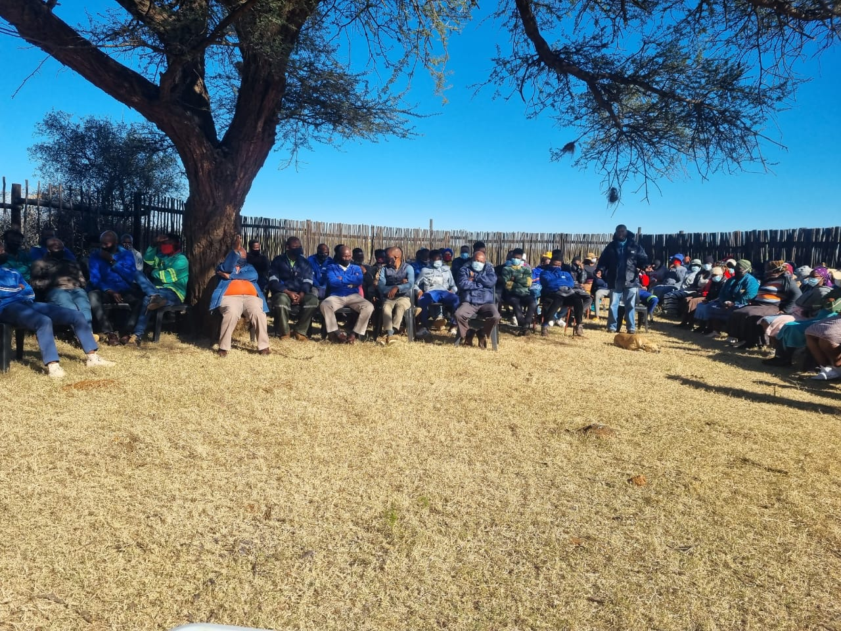
Year  ngwaga | 2021 | May | June | 2021 | 2021 | 2021 | 2021 | 2021 | 2021 | 2021 | 2021
Palo ya Pitso ya morafe |  | 136 | Nil
Structures and committees established since 2010
TSAMAISO YA KGOTLA YA BATLHAPING BA GA MAIDI-GOTLA YA GA TSHITE- PICONG
VILLAGE COMMITTEES as at 18-07-2019
KOMITI YA TIRO | MALOKO A KOMITI
Komiti ya basha/youth committee | - Oduetse Gabonnwe  - Dukkie Maruping  - Keneilwe Gaoboihe
Temo le Thuo/livestock | - Rre Thatayakgosi Motlhabane  - Rre Modisaotsile Valala Gasetlolwe  - MmeNaledi Sebico
Metsi/Water | - Mme Poppy Kgope  - Mme Peggy Mocwiri  - Mme Boheto Mocwiri  - Rre Lenong Manthe  - Mme Mapaseka “Pazo” Matrass  - Morwane Seetelo
Ditlhabololo tsa kgwebo
Tshireletso ya Motse/Public Order | - Mme Manthibogelang Maruping  - Mme Morwane Seetelo  - Rre City Madzinza  - Re Mothusi Khudunyane
Tsa Sedumedi/Faith Based Organization | - Baruti /religious Leaders  - Rre Buru Maroke  - Rev Thatayakgosi Motlhabane
Kabo ya ditsha/mabala/Site allocation | - Rre Wanda Sereo  - Rre Phomolo Kwena  - Kgosi-
Social and Health sector/Tsa Boitekanelo le Katlatlelo Loago | - Rre Phomolo Kwena-Clinic committee  - Mme Poppy Kgope  - Rre Onkokame Matong  - Rre M Mojanaga
Thuto le ngwao
Maleta Motse/Bagakuludi ba Lekgotla | - Rre Lenong Manthe  - Rre Modisaotsile Valala Gasetlolwe  - Rre Kagiso (Buru) Gasetlolwe  - Mme Poppy Kgope  - Mme Baby Kemonye  - Rre Matsie Mocwiri  - Mme Jane Modise  - Rre Raditsheke J Diphae  - Rre Mokhutsane  - Mme Manthibogelang Maruping  - Mme Marienyane Thupayatlase  - Rre Pitiki Alexander  - Rre Motseokae Goitseone
BADISA –KGOTLA- | BORRA LEKGOTLA
BADISA –KGOTLA- | - Rre Senyatso Mocwiri
BADISA –KGOTLA- | - Rre Legabura Goitseone
BADISA –KGOTLA- | - Rre Itlhobogeng Sebico
BADISA –KGOTLA- | - Rre Phomolo Kwena
BADISA –KGOTLA- | - Rre Mmutle Mongwaketse
BADISA –KGOTLA- | - Vacant
BADISA –KGOTLA- | Secretary :Rre Lesego Matong
BADISA –KGOTLA- | Ex officio :Bo rangwane ba bogosi/

NB: Participation and membership to village committees is voluntary and all residents’ members of the community are free to be nominated or volunteer their participation.
All are expected to work towards the common good of realizing community development and social cohesion of Batlhaping bag a Maidi in line with development strategy.
By: Kgosi Kesekwaile K Motlhabane (Kgotla ya ga Tshite- Picong -Revised dated 31March 2015).
Arts and Culture and Sports infrastructure projects
In trying to help the young people in recreational activities the following were initiated;
- A meeting was held with department with Arts, culture sports and recreation to present formal request for community library services.
- We are awaiting response as they have indicated a positive intention to submit our request in their annual plan.
- A letter submitted to the department about sports equipment for various clubs.
Mabogo dinku aa thebana- ebile fifing re tshwarana ka dikobo
As a commitment from December 2020 on the launch of a new kgotla, we continue to assist each and every family during the period of bereavement to start with issue of 20 chairs and a tank of water immediate on reporting death or bereavement to traditional leadership. This is a effort to ensure that no family feel in short of sitting for those who come to pay their sympathy, and comforting bereaved familiies. Se ke thuso gore batho botlhe ba eleng baagi ba motse oo wa rona ba se ka ba lemosega go nna kobo dikhutswane kgotsa kobo di magetleng.

Bogosi eleng tsamaiso ya selegae, e lemogile gore maano gaa site go sita loso. Ka jalo thuso e re elemogile ele “sejo sennye ga se fete molomu”, bogolo jang ka nako ya kutlobotlhoko. A re di tlhokomeleng bagaetsho ke tsa rona, gore di thuse bao ba di tlhokang go re gaisa”.
NB Ditilo ga di adimelo ditiro tse di rulagantsweng jaaka mokete wa lenyalo, ,tshirilolo ya matlapa kgotsa mpho ya badimo tswee tswee!!
Year/  ngwaga | 2021 | 2021  January | 2021  February | 2021  March | 2021  April | 2021  May | 2021  June | Total
Palo ya Malapa aa thusitsweng ke kgotla ka ditilo le Jojo tanks |  | 1 | 2 | 0 | 3 | 6 | 5 | 17
2 x Tanks |  | 1 | 2 | 0 | 3 | 6 | 4 | 14
Cumulative number of 20 chairs per family. |  | 20 | 40 | 0 | 60 | 120 | 80 | 320
Other initiatives of local traditional leadership/tsa bogosi:
  - We are in the process of developing our website due to be launched in next semester 2021.
  - As the local Kgosi and part of traditional council of Ba ga Maidi, I am spearheading the building of a modern kgotla at kgotla-kgolo of Baga Maidi at Manthe. It is due to be completed by end July 2021.
INTER-GOVERMENTAL SERVICES
Working together with Government
Improving our main road
The main road via Tshite school has been regravelled as per request. The department of public works and roads has just funded the four kilo meter from just under down road at Ga Mmolaeng near the downslope at Ga Ra Kebegile go fitlhelela fa otswa ka quarry yoo Rabooi. Motsoga pele are “lemme ga le Tshwane le lefifi”.
Some local people were employed as temporary workers and subcontracting was given to two emerging contractors. The road is good and gravel so far but it still need attention for flood/storm water drainage.
On the other side, it seems to have lost the bid to have the road tarred from Manthe via our village Picong. This is despite the fact that some who were rioting or protesting in need of the same road chose to destroy our only government-built community hall.
Electricity
The two high mast light have started working bringing relief to the residence.
At lease both high mast lights are working and additional two are being constructed in the construction at least four local labour were sourced to help dig high mast lights
Basic Services/ Village planning
Bagaetasho ba tla gopola gore re ile ra emisa ka go abela batho ditsha tsa go aga, ka maikaelelo a gore re ithulaganye ka go kopa Greater Taung local municipality planning division go re thuse ka go dira village plan le go lekanya ditsha/stand/sites tsa go ikagela matlo.
Ke motlotlo go itsese baagi ba motse wa rona gore go tshwelela sentle mme re na le leano kakangwa/draft village plan gore mo ngwageng ee tlang re e dirise.
For now we shall allocate sites/stands with caution to those who are ready to build immediately.Attached please find a draft village plan
13. Bokhutlo-Conclusion
A Pula e ne!!

